Title of Paper | Fire Standards Progress Report
Decision or Information | For information
Title and Date of Meeting | Fire Commission Meeting – 14 October 2022
Attachments | None

Summary
This paper provides members of the Fire Commission with a summary of the progress on the Fire Standards. The Fire Standards Board last met formally on 9th September June 2022.

Recommendations
Members are asked to:
- note the contents of this report for information;
- provide ongoing support to officers in enabling and empowering them to engage in the development and implementation of the Fire Standards both in production and when published; and
- encourage the monitoring of the benefits of the Fire Standards in their services.

Current Status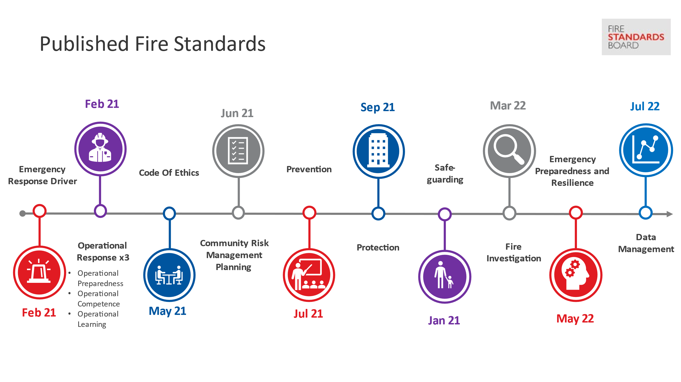
There are now twelve approved and published Fire Standards which are available on the Fire Standards Board (FSB) website and shown in the timeline figure above.
The third phase of Fire Standards was approved at the Board on 15 June 2022. Development on the remaining standards within phases two and three are underway and are shown on the timeline diagram below:
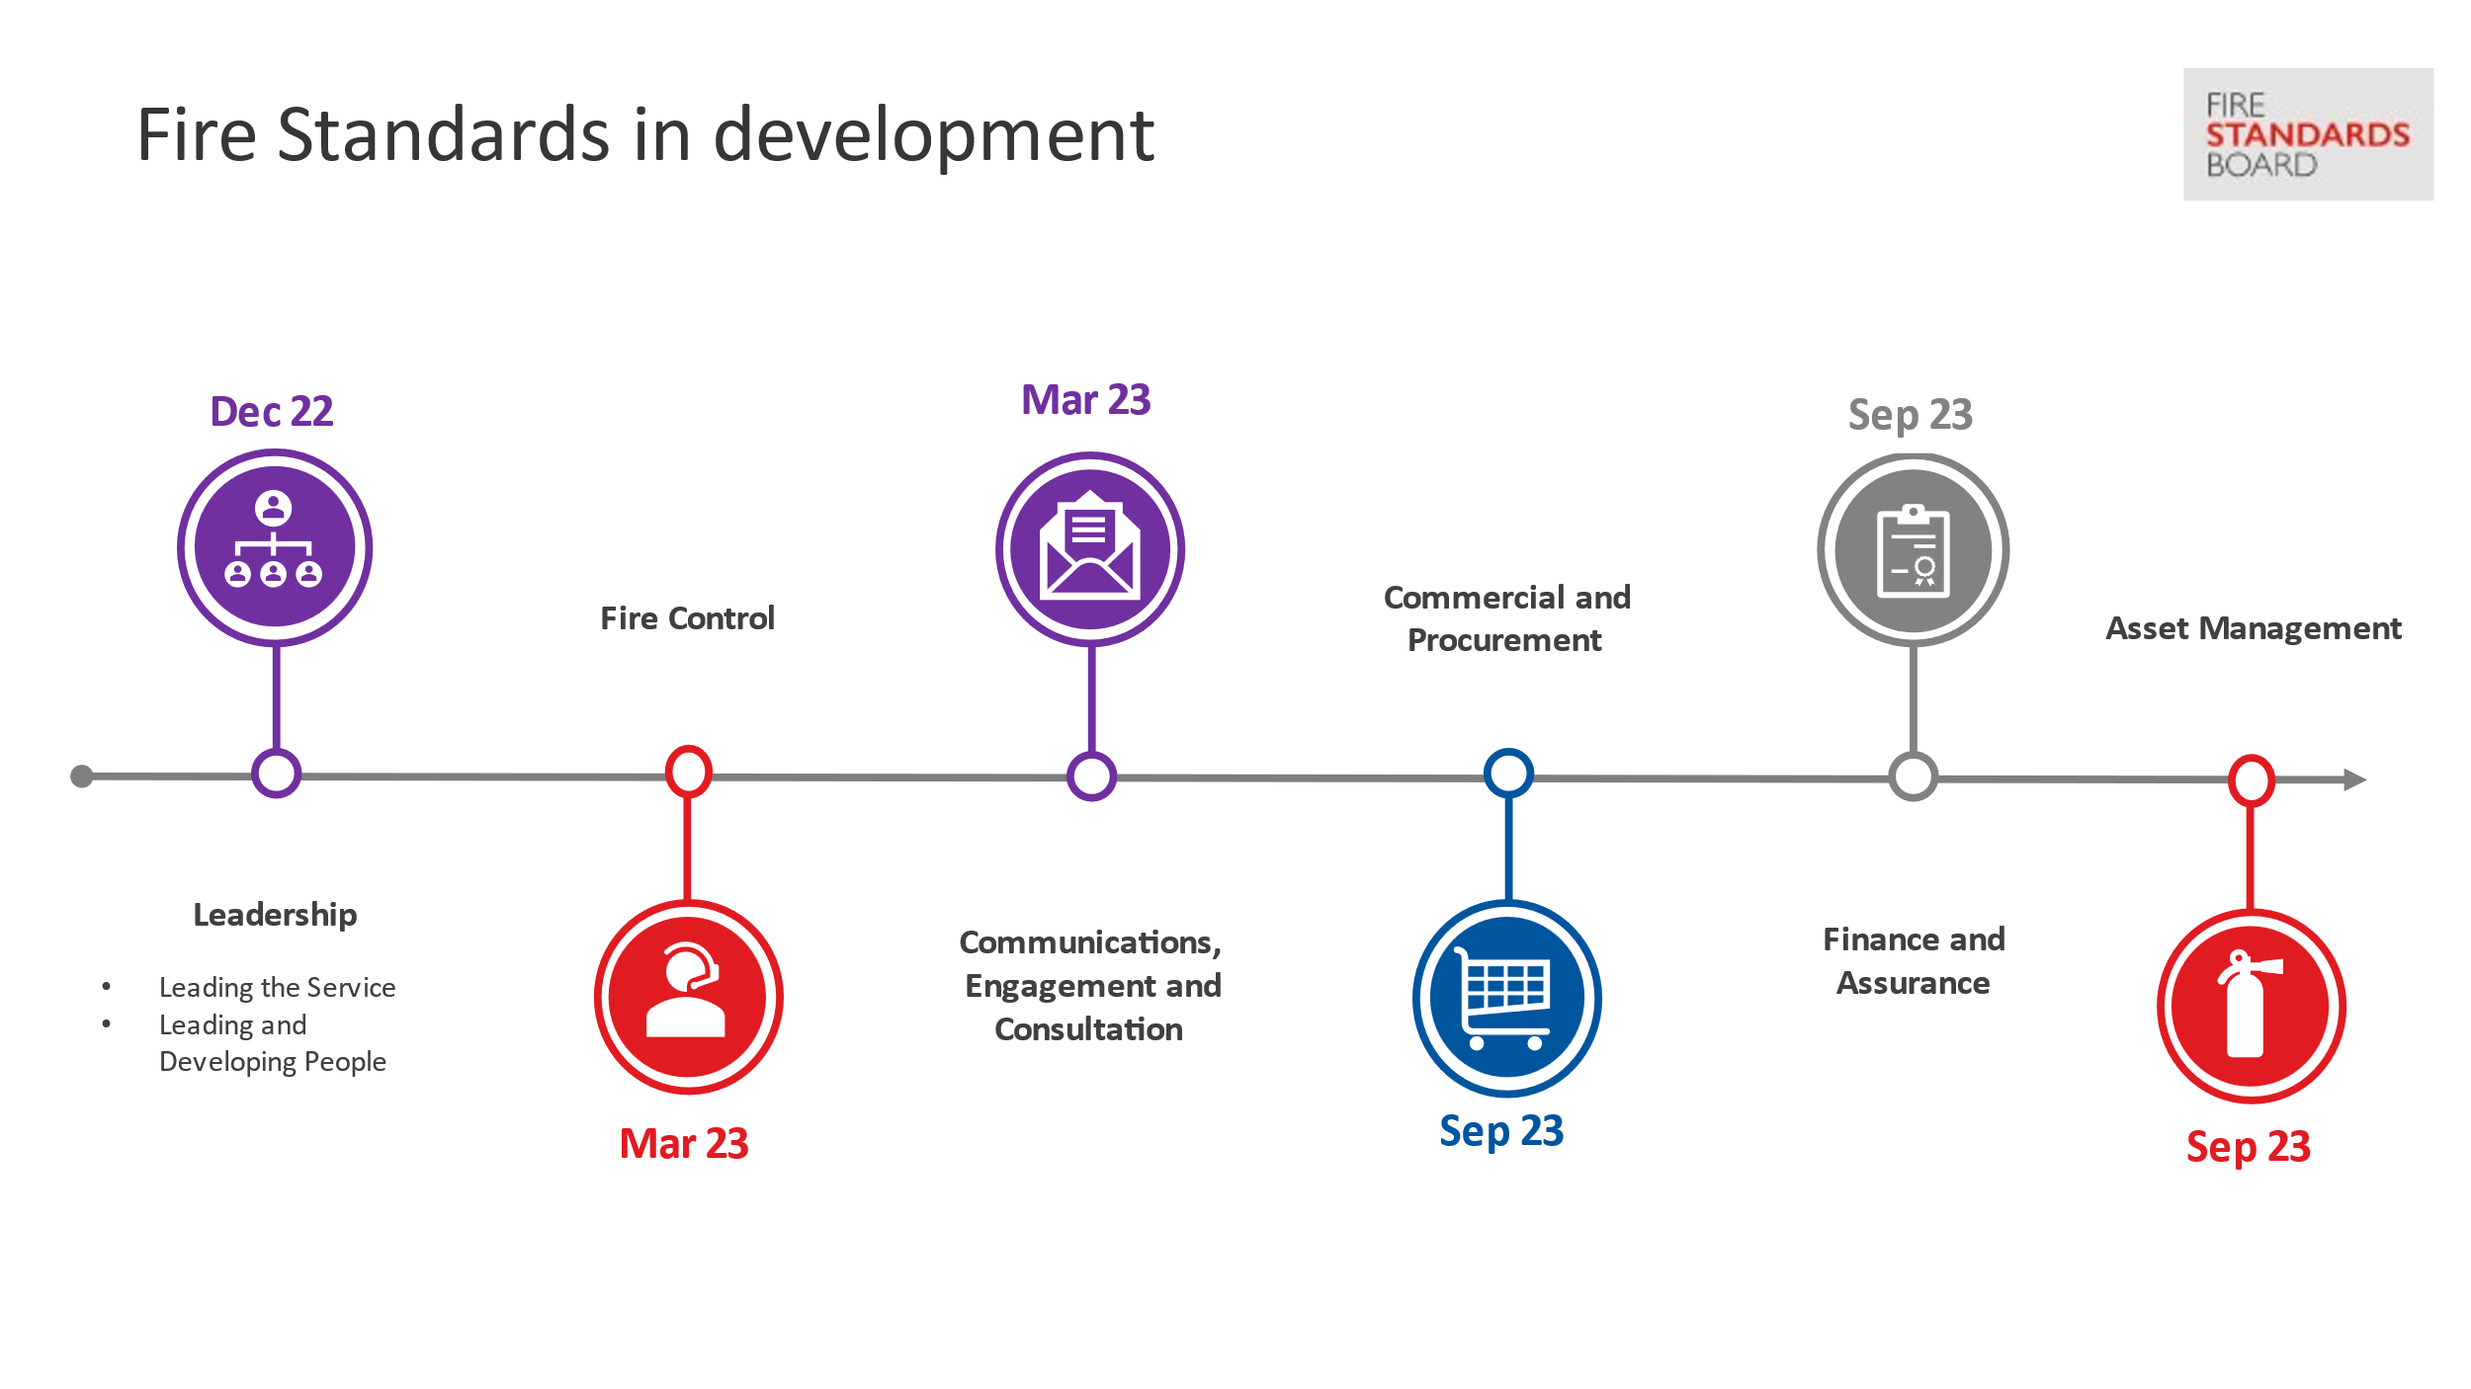

Development Update
Data Management
- Consultation on this standard completed in May 2022.
- Analysis of the consultation responses took place during May to agree any revisions.
- The post-consultation standard was approved by the FSB for quality assurance in June 2022.
- Published July 2022.
Leadership and People Fire Standards
- The Board approved the draft Leadership and People Fire Standards at the Board meeting held in July 2022 and consultation was opened in June 2022
- Engagement with services relating to the consultation on the two Leadership and People Fire Standards took place in July 2022.
- Consultation closed on 9 September 2022 and analysis of the feedback received is currently underway.
- The Fire Standards Team have engaged with HMICFRS to discuss the inclusion of the Leadership and People Fire Standards within the next round of HMICFRS inspections. They are working to establish a good level of maturity within the Fire Standards in preparation for this.
- Subject to consultation feedback, it is expected these standards will be published by December 2022.
Fire Control
- A working group was established in August 2022, the group is comprised of those delivering Fire Control national guidance.
- NFCC’s Fire Control Project Executive, has been identified as Assistant Chief Fire Officer Ben Norman from Greater Manchester Fire and Rescue Service. A commissioning meeting took place on 8 September 2022.
- Development on an initial draft is underway and peer review is expected to have completed by the end of October 2022.
Communications, Engagement and Consultation
- Engagement with the Chair and members of FirePro took place in September 2022 and work was commissioned.
- The proposed scope of this standard would also include the best approaches to partnership working and collaboration.
- Development on an initial draft is underway and peer review is expected to have completed by mid-October 2022.

Remaining Areas for Consideration
A third phase of development work was approved by the FSB at the Board meeting on 15th June 2022. The Board agreed to the following standards for production as part of phase three:
No. | Activity / Potential Fire Standard | Activity Framework Category
1 | Fire Control | Service Delivery
2 | Communication, engagement, consultation | Cultural and Enabling
3 | Commercial and Procurement (Resources) | Enabling
4 | Finance and Assurance (Resources) | Enabling
5 | Asset Management (Resources) | Enabling

Health and Wellbeing has been considered during the development of the Leadership and People Fire Standards. The NFCC People Programme will be undertaking work and producing products relating to health and wellbeing, however, some of this work will not commence until 2023. Therefore, it is proposed that the need for a separate Health and Wellbeing Fire Standard will be reviewed once phase three is complete and the NFCC People Programme has progressed their programme of work.
The current focus on data for the sector is a priority, with digital and technology to follow thereafter. Therefore, work on a Fire Standard relating to digital and technology may be dependent on a variety of influences which yet are unknown. It is proposed that the progression of this work should be reviewed in 2023. The influences include, but are not limited to:
- the work of the NFCC Digital and Data Programme;
- the evolution and impact of the Emergency Service Network;
- support for services in improving local infrastructure and systems; and
- evolution of the Incident Recording System and Fire Control Room technology.
It is anticipated that the full suite of standards will total approximately 21.
The FSB has a defined periodic review process in place following publication of a Fire Standard but can initiate an exceptional review should the need arise.

Implementation support
The FSB, through the NFCC Fire Standards and Implementation Teams, will be continuing to support services as they work to achieve the Fire Standards. The NFCC Implementation Team has recently scheduled and are in the process of conducting a series of engagement sessions with services to support them with implementation of the Fire Standards. These are scheduled until April 2023.
Implementation tools are provided with all published Fire Standards.

Impact and Benefits Realisation
The FSB are keen to understand the impact of the Fire Standards now that the first standards have been published. As part of both the development process and the consultation on each Fire Standard we ask services about potential impacts.
The FSB is currently undertaking engagement activity with services to help better understand impacts and review progress to date.
In July, the FSB Chairs supported by the Fire Standards Team, held a pilot engagement event in London to discuss the impact of the published Fire Standards. This event gave those services attending the opportunity to share their experiences and views with other services, as well as the FSB Chairs. Further engagement sessions are planned for 25th October and 25th November 2022.
Early indications from the pilot event feedback show that the Fire Standards are seen as a positive step for the sector, but that they would have more validity if they were clearly referenced through inspection.
However, what also became apparent were some perceptions held by many attendees which highlighted issues that the Chairs and the Fire Standards Team intend to explore further, both at the future engagement events and through service visits. These perceptions are summarised below:
- services not seeing a link between the Fire Standards and inspection judgement criteria leading to interpreting them as two separate measurement mechanisms;
- services not seeing the connections between their own local organisational development or change work in supporting achievement of the Fire Standards outcomes and improved inspection gradings;
- services not understanding that any national guidance which underpins a Fire Standard is there to help services achieve the standard and in doing so services are likely to see service improvements and better inspection outcomes; and
- services were concerned about what appeared to be differing levels of interpretation of Fire Standards by the cohort of HMICFRS inspectors.
It is proposed that further targeted communication may help clarify some misunderstandings and misconceptions the services have. Further proposed actions will be shared once the engagement sessions have completed and a full analysis of feedback has been received.

Background notes for information
The Fire Standards Board (FSB) is responsible for the identification, organisation, development and maintenance of professional standards for fire and rescue services in England. Led by an independent Chair and Vice Chair, membership of the Board includes the NFCC, employers (both the LGA and the APCC) and the Home Office.
The LGA representative on the Board is Cllr Nick Chard.
The FSB continues to meet regularly to review the progress made on Fire Standards development. Its next meeting is scheduled for 21 December 2022.
Given the various stages of development required and the time needed for engagement with services in the early stages, as well as through formal consultation, development work and publications are staggered. This is primarily done to align capacity and resources in a considered way, but also to pace the rate at which standards are released to services.
Once approved, Fire Standards are shared on the Fire Standards Board website.
Services should now be aware of the requirements being placed upon them through these Fire Standards. Her Majesty’s Inspectorate of Constabulary and Fire and Rescue Services (HMICFRS) will be referencing the standards in their inspection arrangements and therefore services should be prepared to evidence their progress towards achieving them.
The Fire Standards Board would welcome and appreciate the support of fire authority chairs and members in:
- Ensuring their services are enabled to engage in Fire Standards by releasing their subject matter experts to support development work and peer review through the NFCC where appropriate and feasible.
- Responding to the Fire Standards consultations as they are published; and
- Supporting activities to achieve those Fire Standards through implementation once approved and published.

FirePro is a network of communications professionals working within all UK fire and rescue services.

